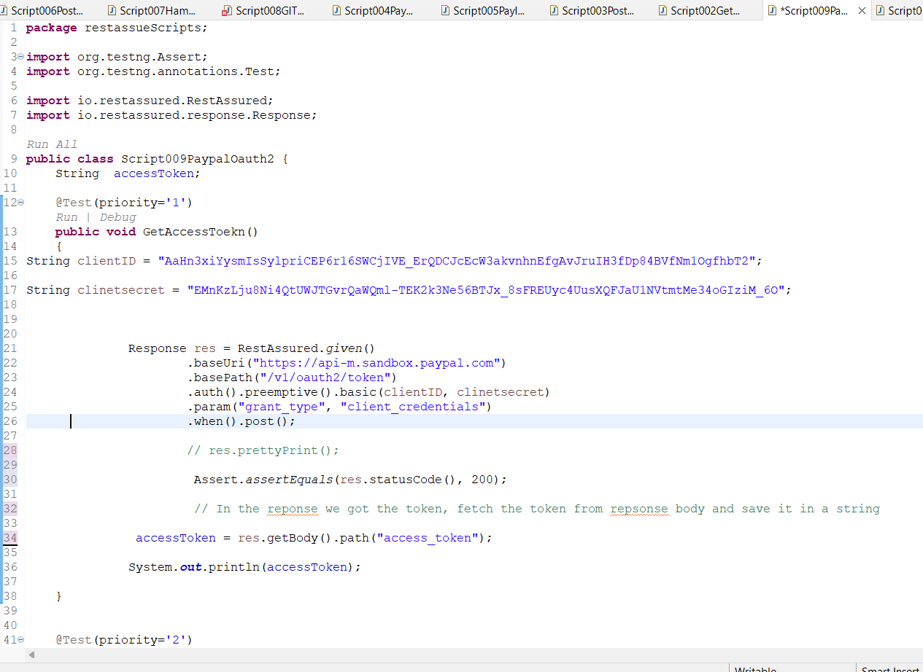

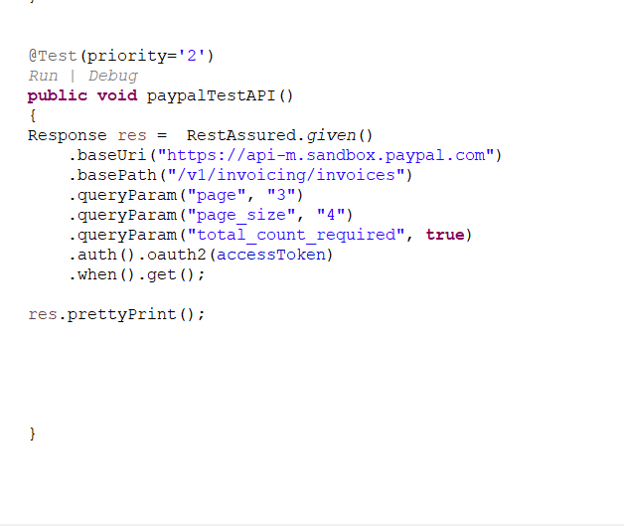

**Console output**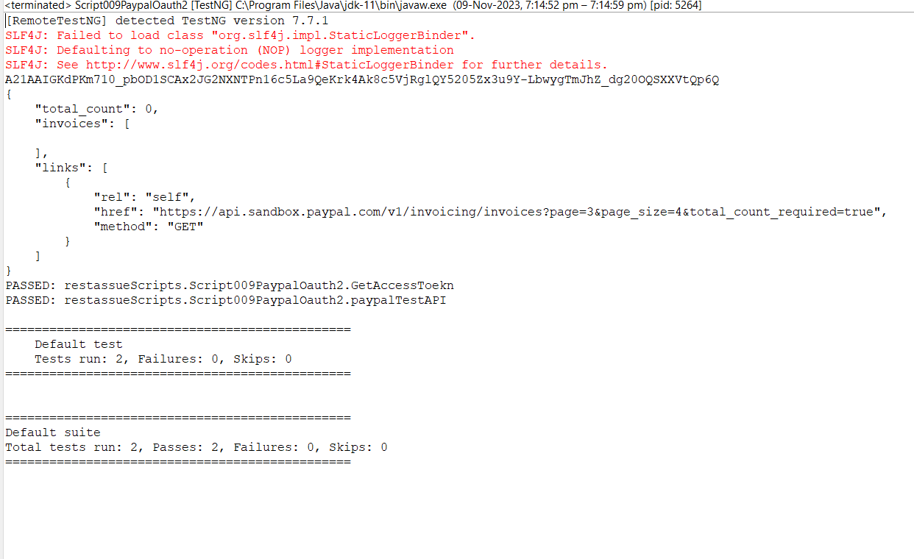

**package** restassueScripts;

**import** org.testng.Assert;

**import** org.testng.annotations.Test;

**import** io.restassured.RestAssured;

**import** io.restassured.response.Response;

**public** **class** Script009PaypalOauth2 {

String accessToken;

@Test(priority='1')

**public** **void** GetAccessToekn()

{

String clientID = "AaHn3xiYysmIsSylpriCEP6r16SWCjIVE_ErQDCJcEcW3akvnhnEfgAvJruIH3fDp84BVfNm1OgfhbT2";

String clinetsecret = "EMnKzLju8Ni4QtUWJTGvrQaWQml-TEK2k3Ne56BTJx_8sFREUyc4UusXQFJaU1NVtmtMe34oGIziM_6O";

Response res = RestAssured.*given*()

.baseUri("https://api-m.sandbox.paypal.com")

.basePath("/v1/oauth2/token")

.auth().preemptive().basic(clientID, clinetsecret)

.param("grant_type", "client_credentials")

.when().post();

// res.prettyPrint();

Assert.*assertEquals*(res.statusCode(), 200);

// In the reponse we got the token, fetch the token from repsonse body and save it in a string

accessToken = res.getBody().path("access_token");

System.***out***.println(accessToken);

}

@Test(priority='2')

**public** **void** paypalTestAPI()

{

Response res = RestAssured.*given*()

.baseUri("https://api-m.sandbox.paypal.com")

.basePath("/v1/invoicing/invoices")

.queryParam("page", "3")

.queryParam("page_size", "4")

.queryParam("total_count_required", **true**)

.auth().oauth2(accessToken)

.when().get();

res.prettyPrint();

}

}